Shelter Care Ministries

Name
Affiliation
Date

Shelter Care Ministries
Since its foundation in 1985, shelter care has been handling the needs of families and individuals at risk f homelessness or homelessness, most of whom live with severe mental illness. Shelter care ministries provide different programs to society. First, the supportive housing program addresses the long- and short-term goals for families to obtain stability. Many individuals and families with children risk losing their homes or being homeless in Rockford II. the ministry aims at solving the housing challenge for such individuals. There are also individuals with mental problems who are in danger when they lack a place to gather. The care ministries operate four distinct programs that help such individuals move from homeless to housing.
The use of rhetoric appeals, for instance, ethos, pathos, and logos, to attract viewers to participate in their program and services is a practice that many non-profit organizations have embraced for years. From worldwide organizations to local ones, the benefits of such a practice are precious. This is well demonstrated in the web page of the Shelter Care Ministries (https://shelter-care.org/). A web page that is committed to attracting and targeting different audiences of different social statuses. This paper aims to highlight how the shelter care ministries website has incorporated different elements into its site as a measure of exhibiting its programs, services, and missions. The web page can effectively target its audience by carefully utilizing rhetorical elements of pathos, ethos, and logos.
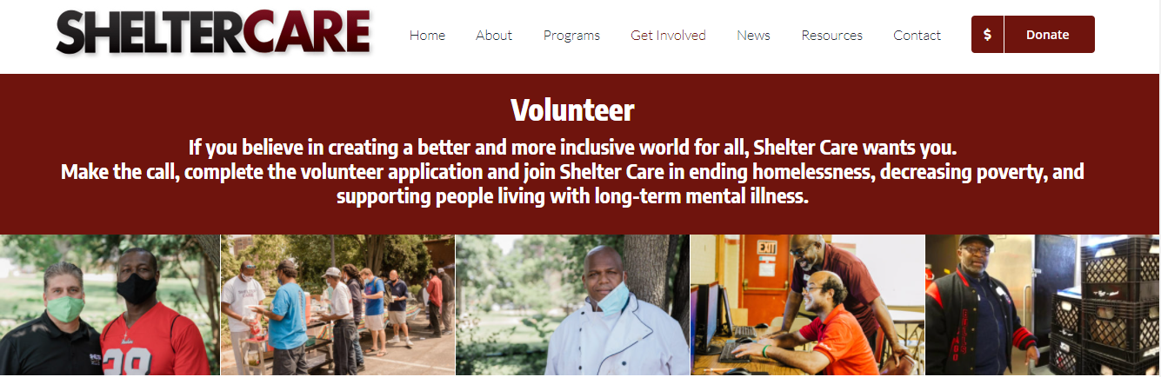
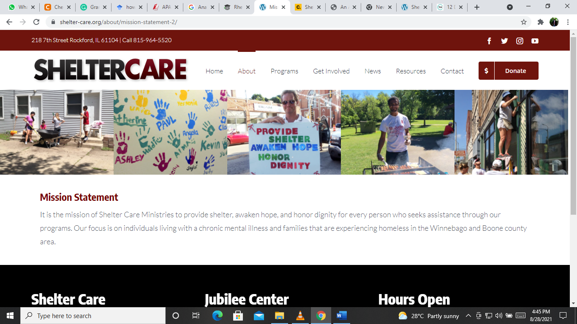
The website https://shelter-care.org/ has been well crafted as a medium that presents various services of shelter care ministries. Pathos represents a rhetorical device that appeals to the emotions of the user or reader. The ministries’ website uses many images and pictures which display the individuals who help shelter care ministries. These individuals are helped by the care ministries and the community in general. By using such images and including descriptions on the website regarding how people will find help In the different programs, shelter care ministries can help a viewer to the website feel the usefulness of the ministries and that the ministries are worthy of donation helps. The ministries’ mission also has an impact on the viewer’s emotion.

The website also uses ethos as a persuasive appeal. Through images and words, shelter care ministries attempt to persuade the website visitor to either take advantage of the services offered or help the ministries continue offering services. For instance, shelter care ministries taking advantage of ethos is their protuberant display of donation chances and opportunity to shop at Amazon to fund their programs and help community members with mental challenges. The website also tries to make the viewer feel that shelter care is giving back to society and that the visitor's help can strengthen the community and make it a better place for homeless families.
Its website also uses images of children who are usually associated with innocence and purity. Since small children have the characteristics mentioned earlier, their images act as triggers for the audience's emotions irrespective of any factors. This is an effective aspect of pathos utilized by shelter care ministries. Such images aim to impact the target audience in different ways.

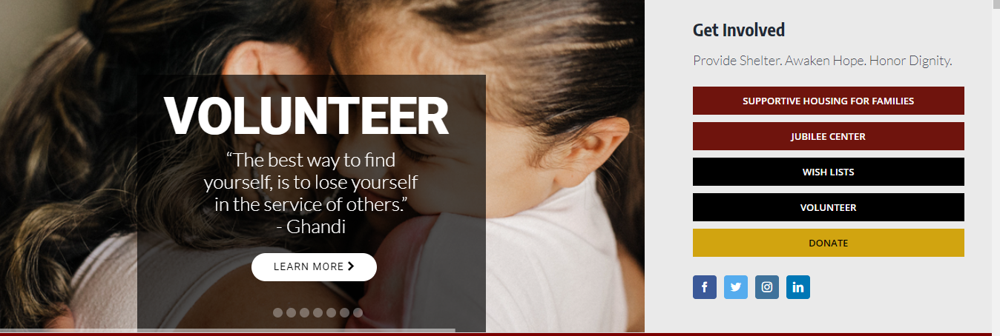
The website also consists of an easy way to find the donation button. Besides, website visitors should find the donation like or button within the shortest time possible. Shelter care ministries’ website consists of a button on the top navigation of the website’s header. The button can be easily located as it uses a shade of orange to highlight. Such a choice of color also attracts the eye. since many visitors require persuasion to donate, the website has strategically placed donation calls to action throughout the website, including few sentences inviting visitors to join shelter care ministries in making a difference. The donation button also is directly linked to the donation process. When the visitor clicks the link, it takes the individual immediately to begin the donation process. The website also includes reasons why donating is crucial to vulnerable families. The primary objective of such a website is to convince visitors to be part of the ministry in different ways. Not every visitor to the website offers a donation. However, the compelling and short reason why the visitors should give offers an understanding to the website visitor, thus motivating them to donate.
The website is also functional and well-designed, thus reflecting the ministries’ brand and services. The website is visually appealing, professional, and polished. The web page also consists of uncluttered layouts, quality graphics, and photographs, making the message shines. The website speed and functionality is crucial as it is always the first impression of visitors. Poorly constructed and slow websites usually leave the website visitors discouraged and frustrated. The website is also easy to use. The UX has played a major role in assisting the visitors in staying and understanding shelter care ministries’ websites. The website consists of logical and obvious navigation with a clear hierarchy. It also consists of visual cues and a consistent layout for easy navigation.
The shelter care website also consists of new and interesting quality content. The website avoided the use of acronyms, corporate speak, and jargon. The avoidance of such tools is crucial since most of the visitors usually have short attention spans. The website is also readily accessible through location and contact. Thus, it is easy to engage with them through different social media platforms. Besides the location and contact details, the website also has a google map.
In conclusion, rhetorical elements, pathos, ethos, and logos are massively evident in the website. However, there is a lack of utilization of video commercials which could have greatly impacted the conveyance of the message. Analyzing different rhetorical elements fused in the web page demonstrates how shelter care ministries are committed to their mission. By presenting their unique programs and services, shelter care ministries can serve mentally ill individuals and homeless families.
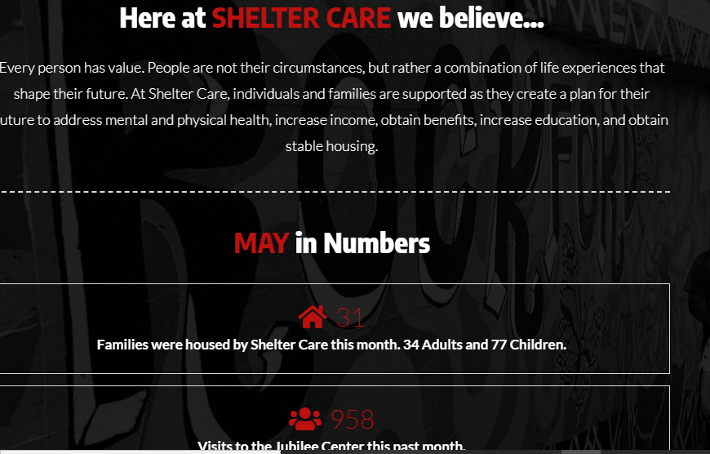
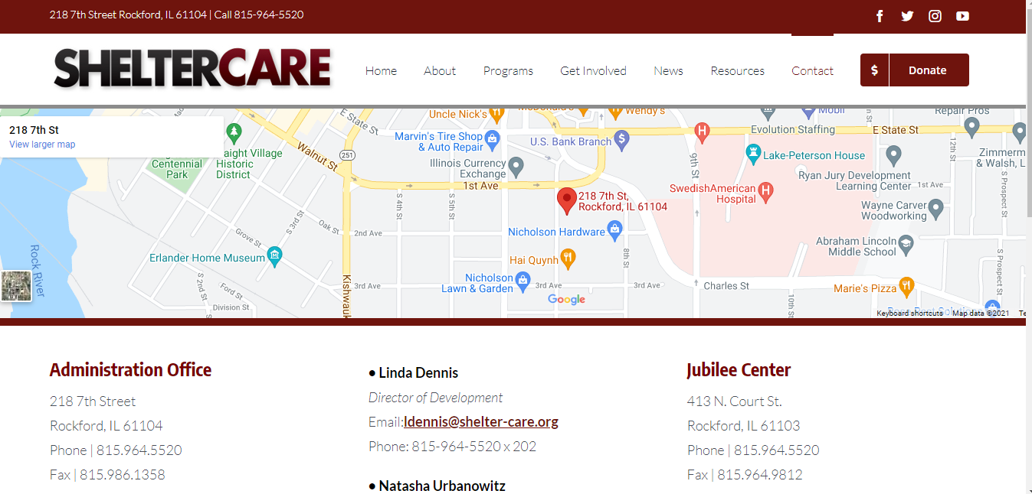
References
(2014, October 26). Shelter Care. https://shelter-care.org/

